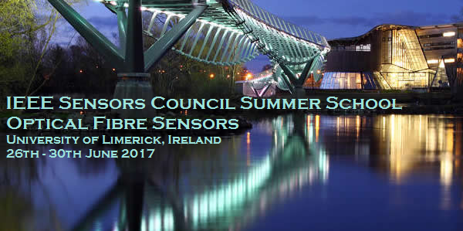IEEE Sensors Council invites you to join the 2nd Edition of its Summer School Series at the University of Limerick, Ireland from the 26th – 30th June 2017. Continuing the multi-disciplinary nature of last year’s hugely successful Summer School, this School will focus its attention on Optical Fibre Sensors. The School will feature a mix of Lectures, Keynote Talks and Poster Sessions together with a number of networking opportunities for students to engage further with the lecturers. Keynote lecturers include Prof. Michel Digonnet, Stanford University; Prof. Francis Berghmans, Vrije Universiteit Brussels; Prof. Brian Culshaw, University of Strathclyde; Prof. Andrea Cusano, University of Sannio, and Prof. Sile Nic Chormaic, Okinawa Institute of Science and Technology, with more to be confirmed.
The School will cover a wide range of topics, including:
- Chemical fibre sensing
- Fibre gyroscopes
- Specialty fibres for sensing
- Biomedical fibre sensors
- With a special focus on pushing the boundaries of the micro- and nano- scale fibre sensors, e.g:
  - Lab-on-Fibre technology
  - Fibre top cantilever sensors
  - Optical cavities and sensing
For more information on the IEEE Sensors Council Summer School Series visit: http://ieee-sc-summer-school.org/

